https://www.jdoodle.com/embed/v0/5YcN
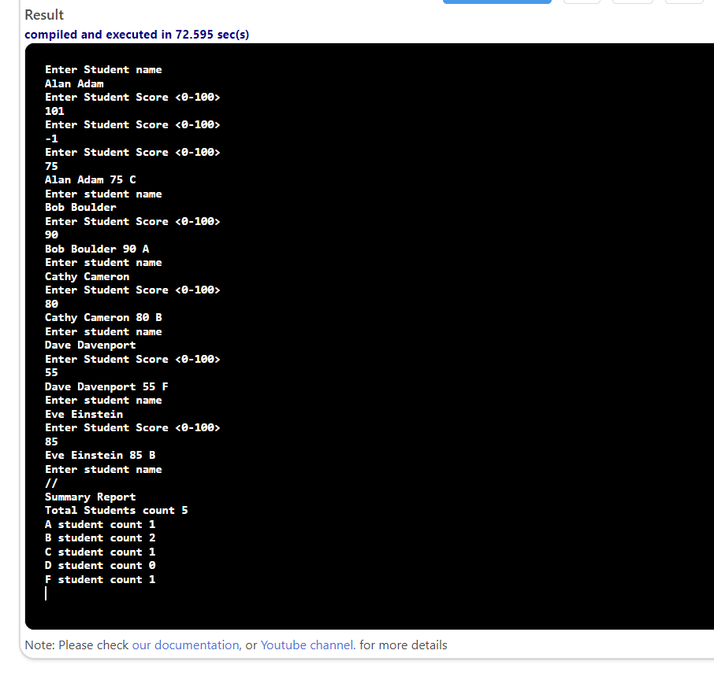

#include <iostream>
using namespace std;
int main()
{
int score;
string name;
int aCount = 0, bCount = 0, cCount = 0, dCount = 0, fCount = 0;
cout << "Enter Student name" << endl;
getline(cin, name);
int count = 0;
while (name != "//")
{
do
{
cout << "Enter Student Score <0-100>" << endl;
cin >> score;
cin.ignore();
}
while (score < 0 || score > 100);
count++;
char grade;
if (score >= 90.0)
{
grade = 'A';
aCount++;
}
else if (score >= 80.0)
{
grade = 'B';
bCount++;
}
else if (score >= 70.0)
{
grade = 'C';
cCount++;
}
else if (score >= 60.0)
{
grade = 'D';
dCount++;
}
else if (score <= 60)
{
grade = 'F';
fCount++;
}
cout << name << " " << score << " " << grade << endl;
cout << "Enter student name" << endl;
getline(cin, name);
}
int totalCount = aCount + bCount + cCount + dCount + fCount;
cout << "Summary Report" << endl;
cout << "Total Students count " << totalCount << endl;
cout << "A student count " << aCount << endl;
cout << "B student count " << bCount << endl;
cout << "C student count " << cCount << endl;
cout << "D student count " << dCount << endl;
cout << "F student count " << fCount << endl;
return 0;
}

